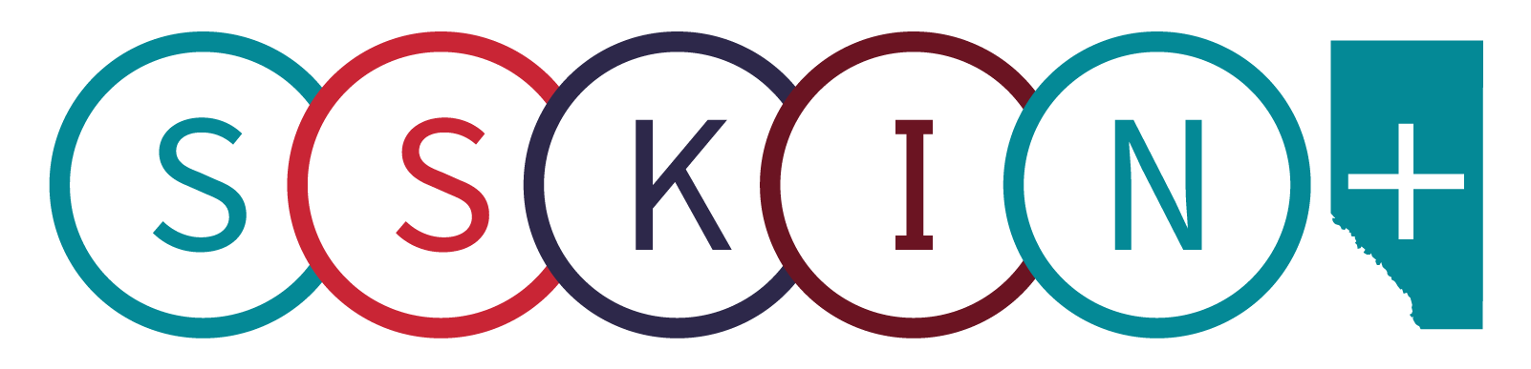
World Wide STOP Pressure Injury Day Activities 2021

Date: November 23, 2021

To: office@EPUAP.org

Dear EPUAP
Covenant Health and Alberta Health Services (AHS) have collaborated to develop awareness and education materials to celebrate World Wide Stop Pressure Injury Day 2021. This year we prepared two toolkits: one for healthcare providers and one for patients, residents, families and caregivers (attached). The greatest success this year is that we collaborated across the province to engage teams, built relationships and strengthen our commitment to preventing pressure injuries. Here are some photos from this year!

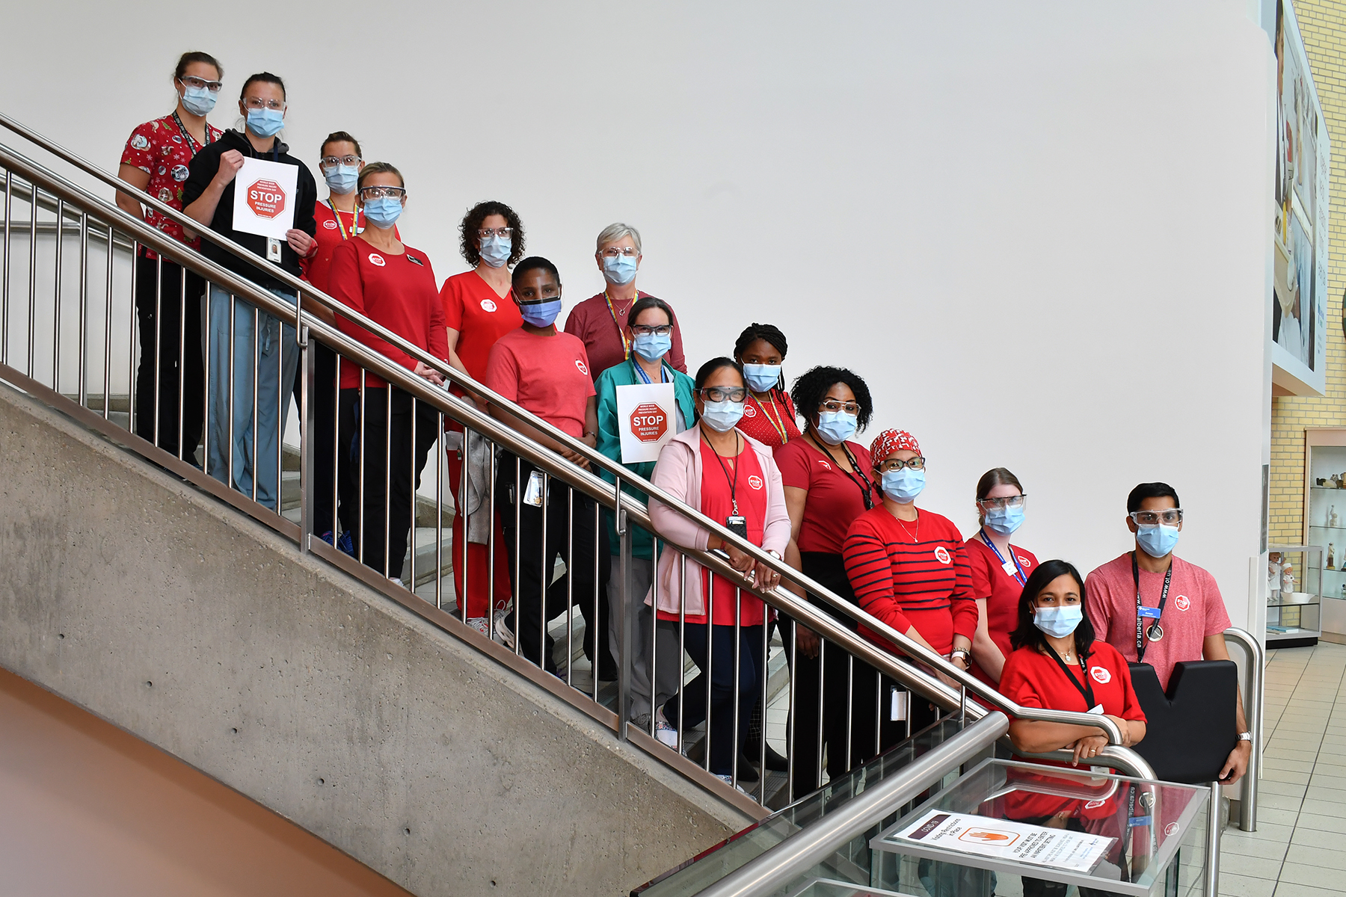
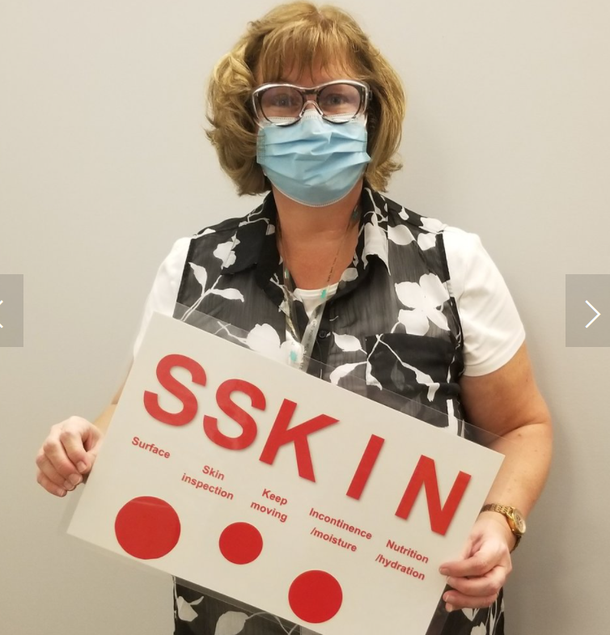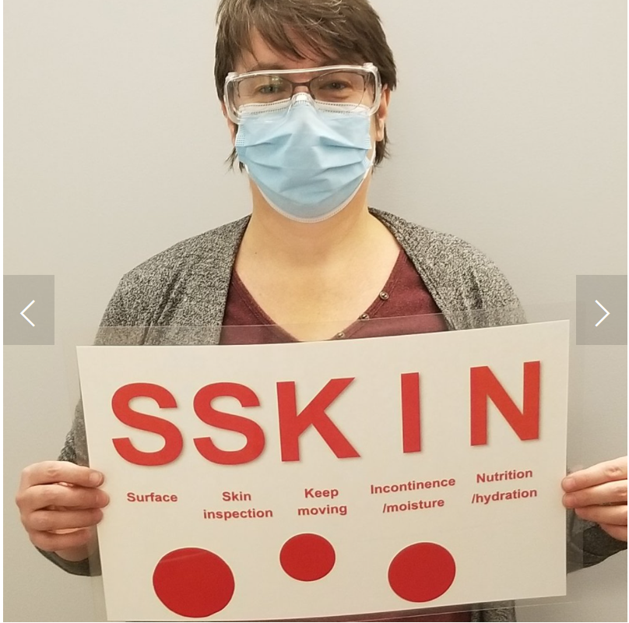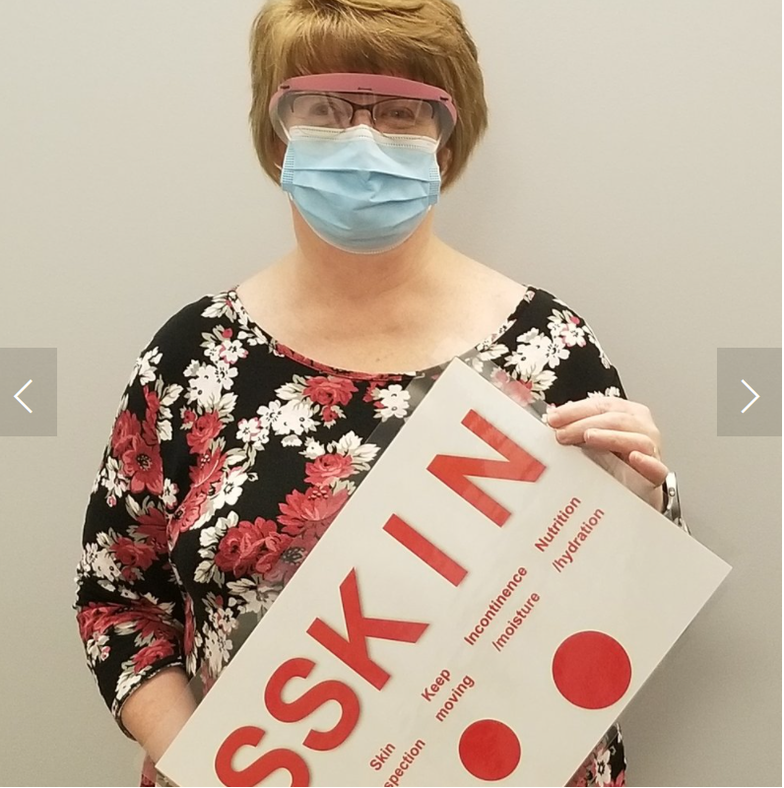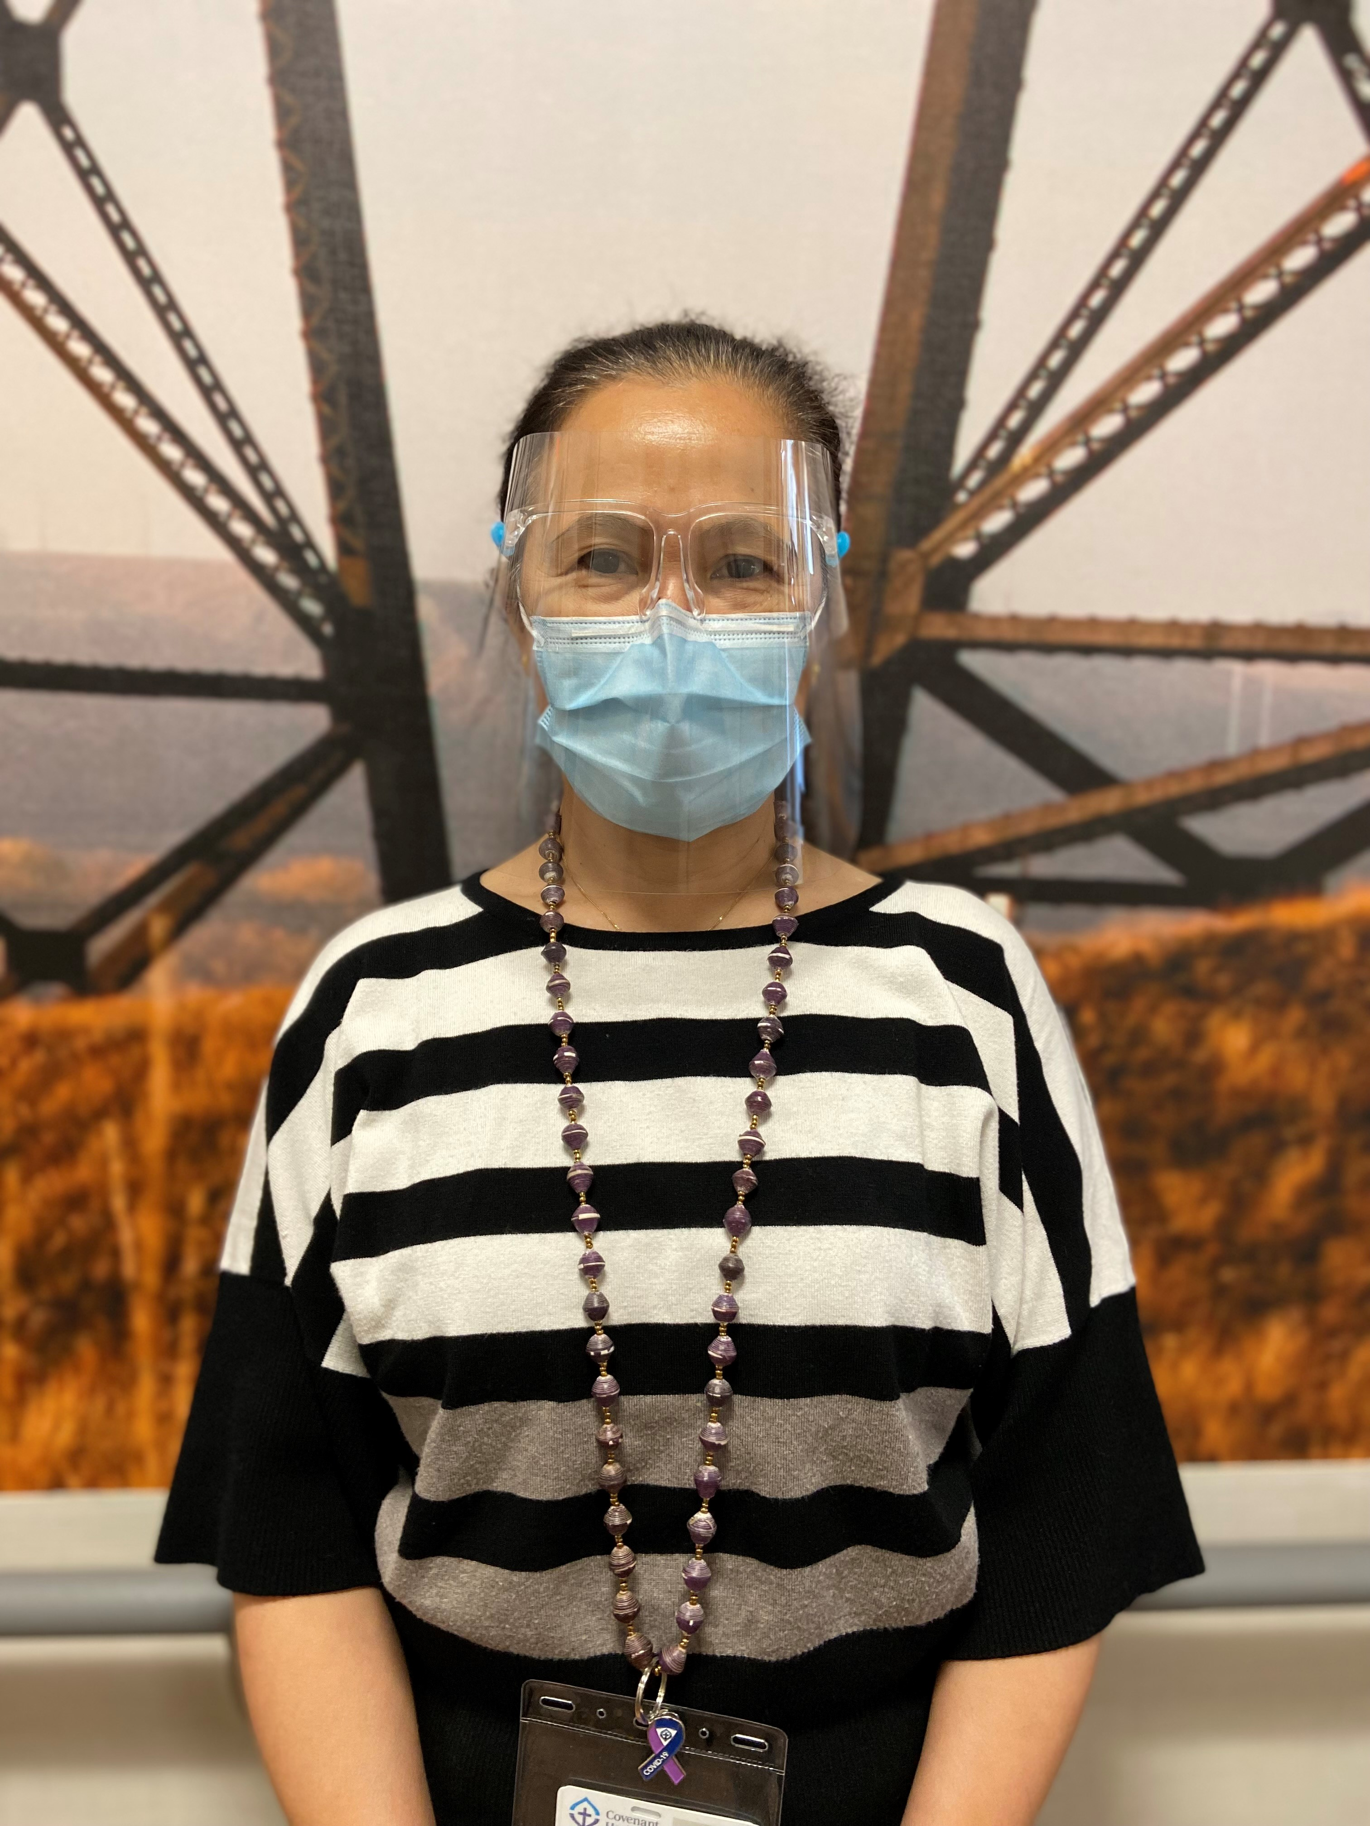

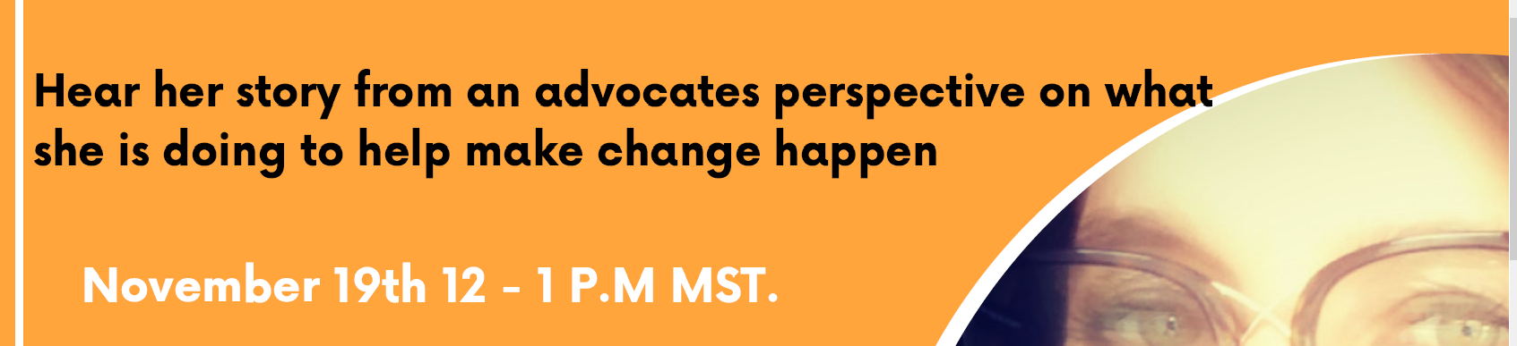

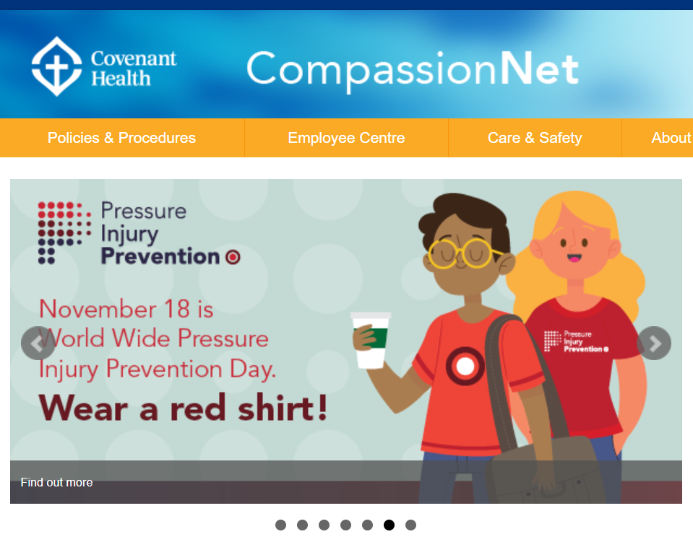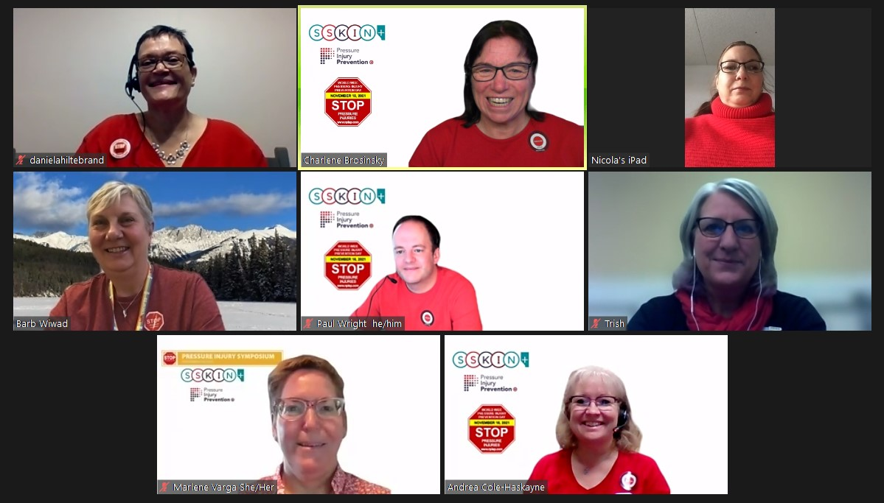

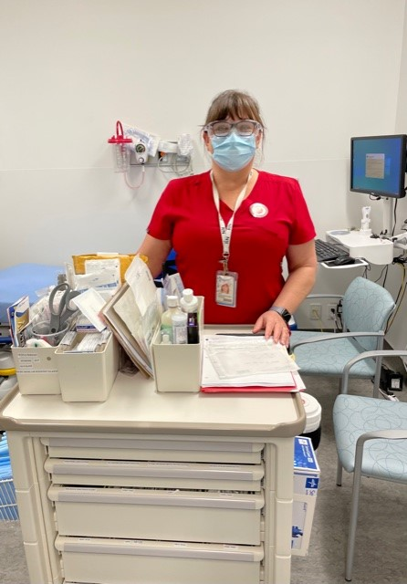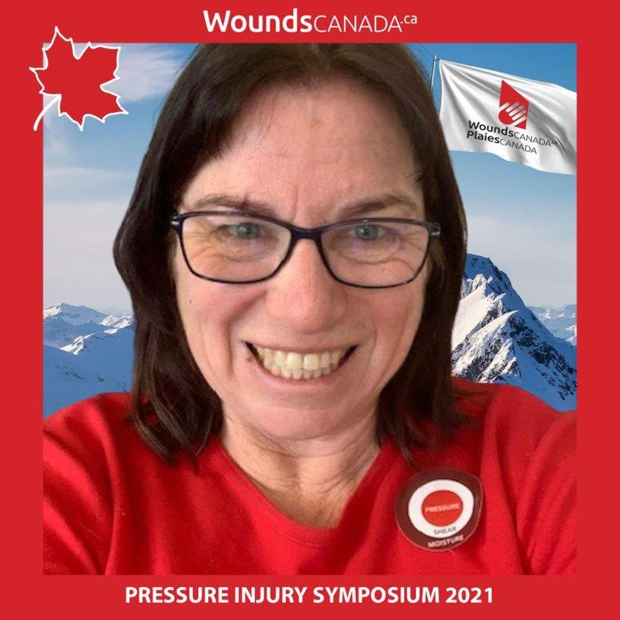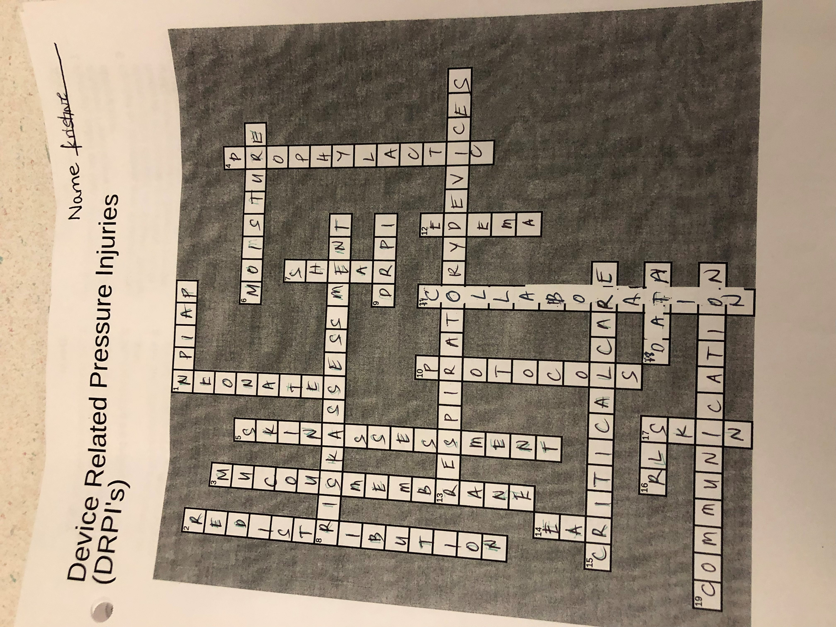
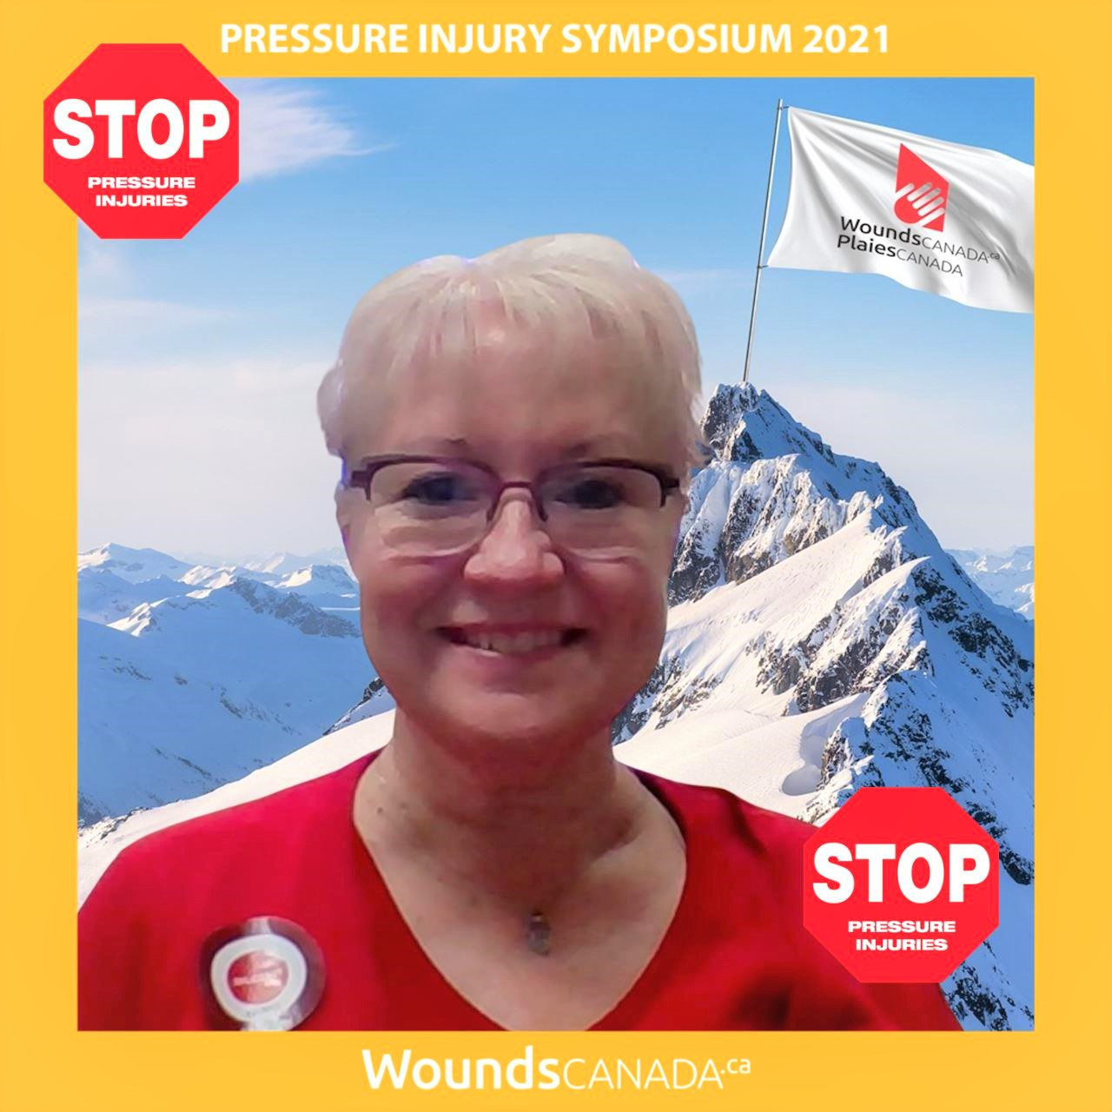
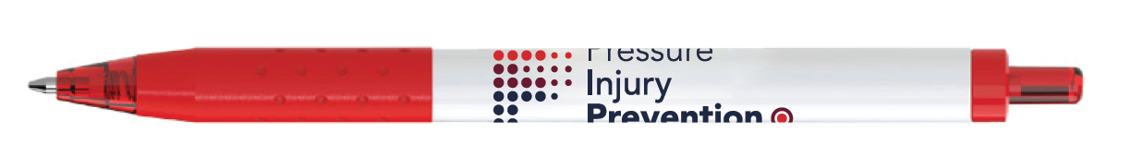
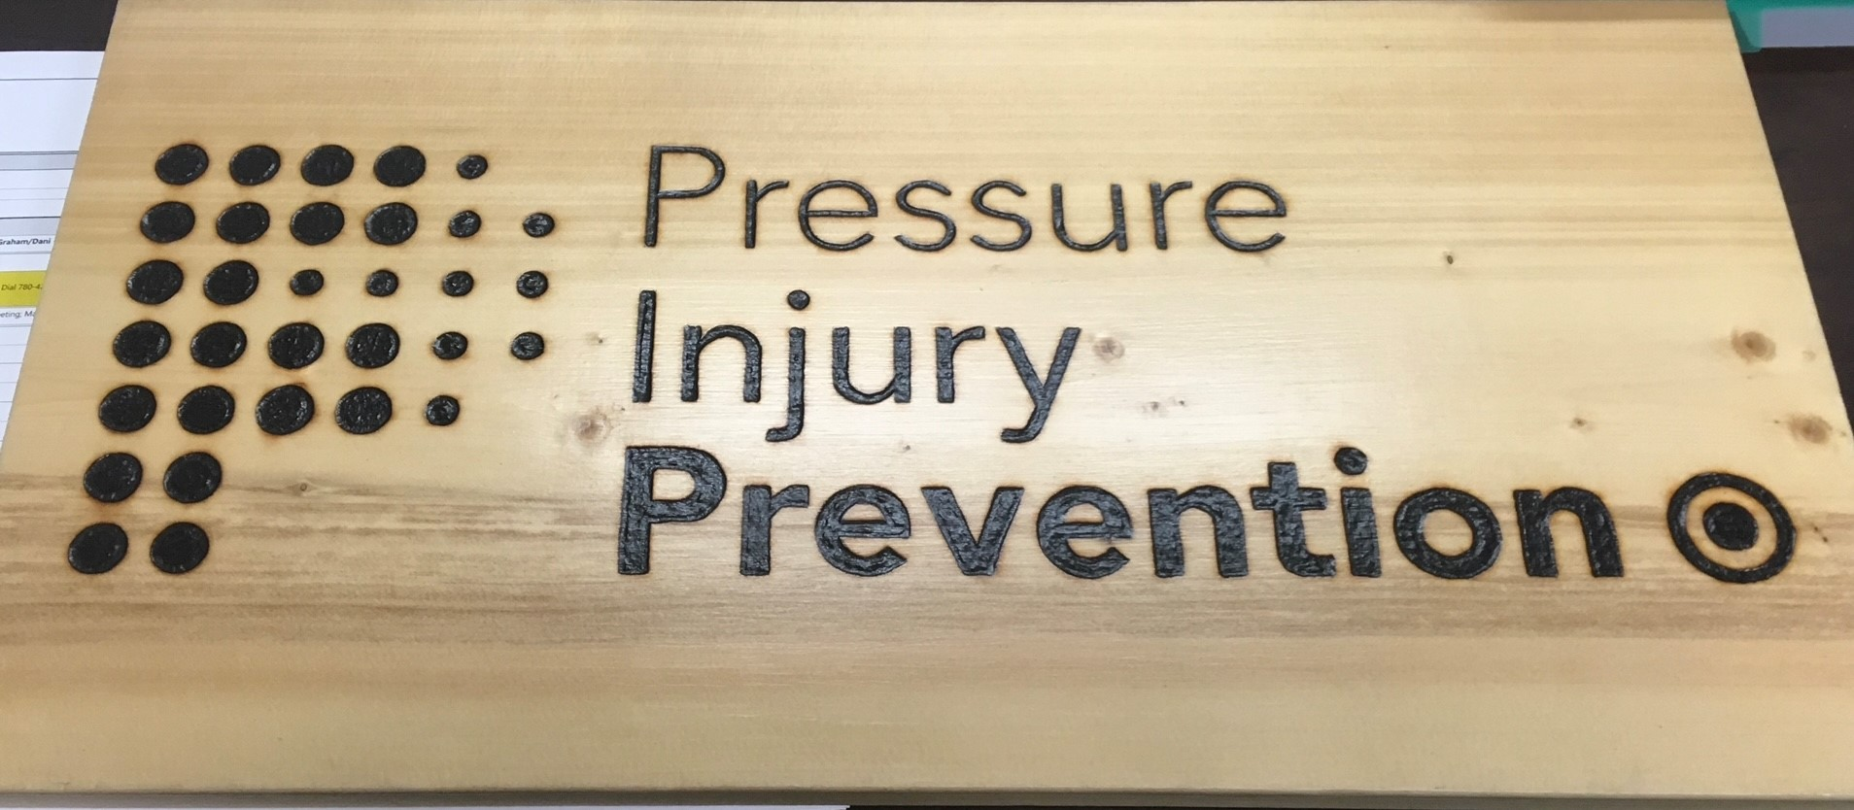

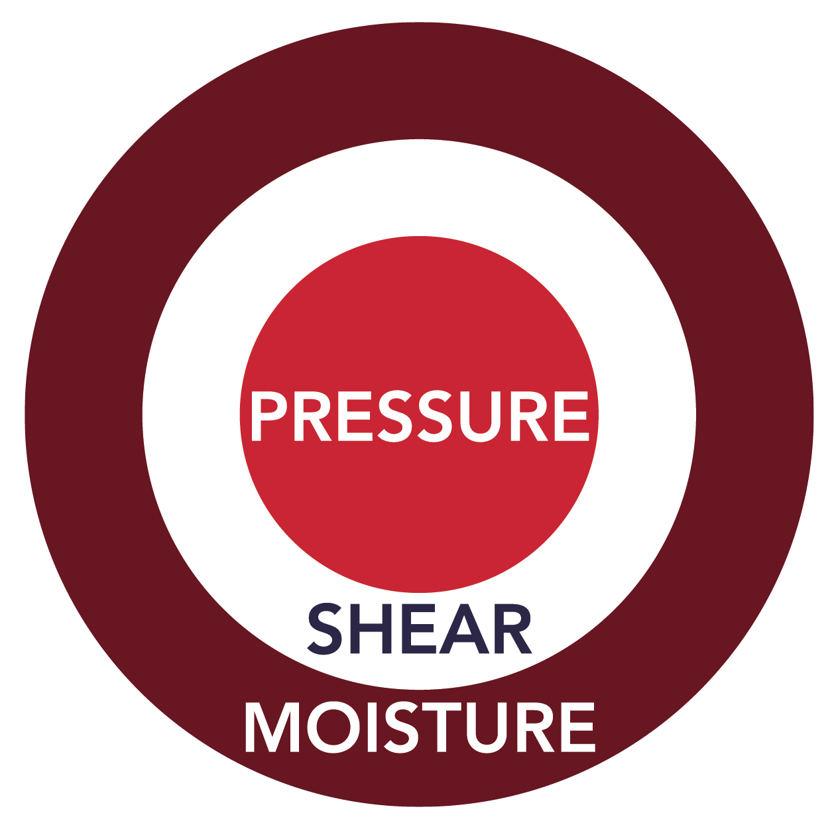

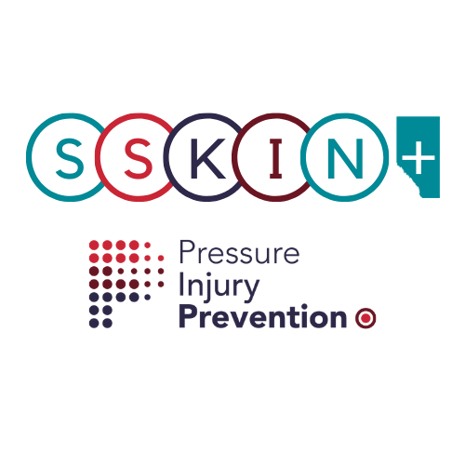
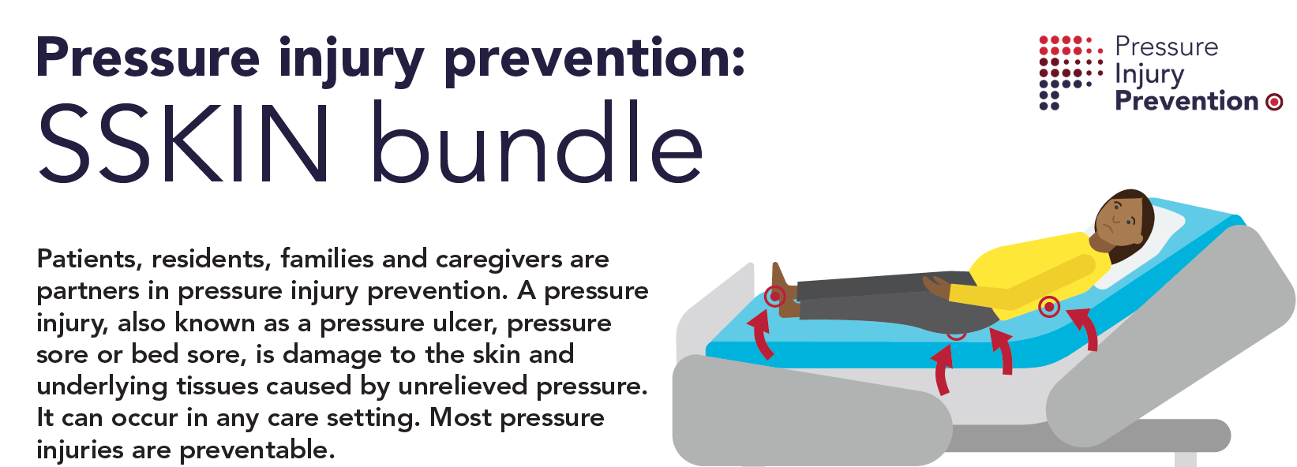

Warm regards

Marlene Varga Chair World Wide Stop Pressure Injury Day Planning Committee
Marlene.Varga@Covenanthealth.ca

