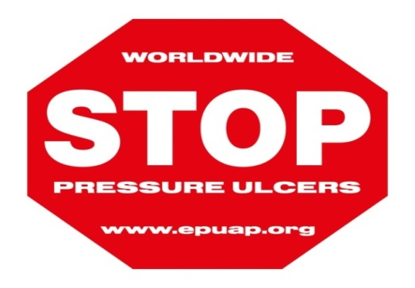
World Wide Stop Pressure Ulcer Day is an annual event bringing all Health Care Professionals together to raise awareness and highlight the importance of Stop Pressure Ulcers. November 21st was a very exciting day at Our Lady of Lourdes Hospital whereby the multidisciplinary team united together to deliver education and information emphasising the importance of pressure ulcer prevention and management to staff, patients and public. This is a powerful celebration encouraging the conversation around STOP the PRESSURE! It was great to see staff showing incredible interest and enthusiasm in highlighting the importance of patient safety and promoting patient centred care. Great fun was had by everyone. On behalf of the Tissue Viability team we would like to thank the sponsors and the people who contributed towards making this a successful and enjoyable day.
