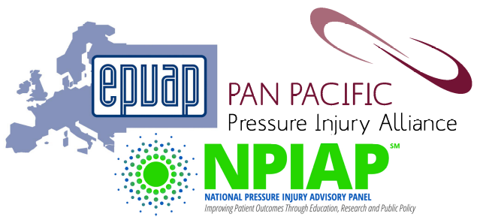

International Pressure Ulcer/Injury Guideline
(full Clinical Practice Guideline and abridged Quick Reference Guide)

TRANSLATION REQUEST FORM

The European Pressure Ulcer Advisory Panel (EPUAP), National Pressure Injury Advisory Panel (NPIAP), and Pan Pacific Pressure Injury Alliance (PPPIA) welcome translations of the Clinical Practice Guideline (CPG) and Quick Reference Guide (QRG) into languages other than English.

Please review the TRANSLATION INFORMATION SHEET available from the EPUAP website before completing this request form.

For more information and to submit this translation request form contact BOTH:
- EPUAP Office office@epuap.org and
- Guideline Committee translation@internationalguideline.com

Contact Details for EPUAP Business Office:
c/o Codan Consulting Provaznická 11, 110 00 Prague Czech Republic
Tel: +420 251 019 379
Fax: +420 251 019 360

TRANSLATION REQUEST

Contact name: …………………………………………………………………………………………………………………………………
Translating organisation: ………………………………………………………………..………………………………………………..
Name and position of authorised signatory:………………………..………………………………………………………….
Email address: …………………………………………………………………………………………………………………………………
Language for translation: ……………………………………………………………………………………..…………………………
Document requesting to translate (tick or highlight):
□ Quick Reference Guide
□ Clinical Practice Guideline (fees apply)

Outline your proposed translation process:

Declarations
I confirm that I am authorised to sign the declaration:

Organisation: ……………………………………………………………………………………………………………………………….
Name: ……………………………………………………………………………………….………………………………………………..
By signing this declaration:
- I acknowledge that EPUAP, NPIAP, and PPPIA retain copyright of all versions of the Clinical Practice Guideline and Quick Reference Guide.
- I confirm that neither I nor my organisation will profit financially from the translated version of the Clinical Practice Guideline or Quick Reference Guide.
- I confirm that I and my organisation will follow the requirements for translation as set out on the Translation Information Sheet available from the EPUAP website.
- I confirm at least four appropriate translators will be involved in the translation process.
- I confirm that a copy of the translated QRG will be sent to the EPUAP Office and Guideline Translation Committee (see contact above) to be placed on the EPUAP website.
- I confirm that the completed QRG translation will be provided within 12 months of receiving exclusive translation rights.
- I confirm that the translation team gives permission for the translation process to be reported in any quality improvement/implementation reports on the translation of the guideline that might be prepared by the EPUAP/NPIAP/PPPIA. This information will be deidentified of translators and translating organisations.

Name: ……………………………………………………………………………………………………………………………………………

Signature: ……………………………………………………………………………………………………………………………...……….

